WEEK 7 ASSIGNMENT
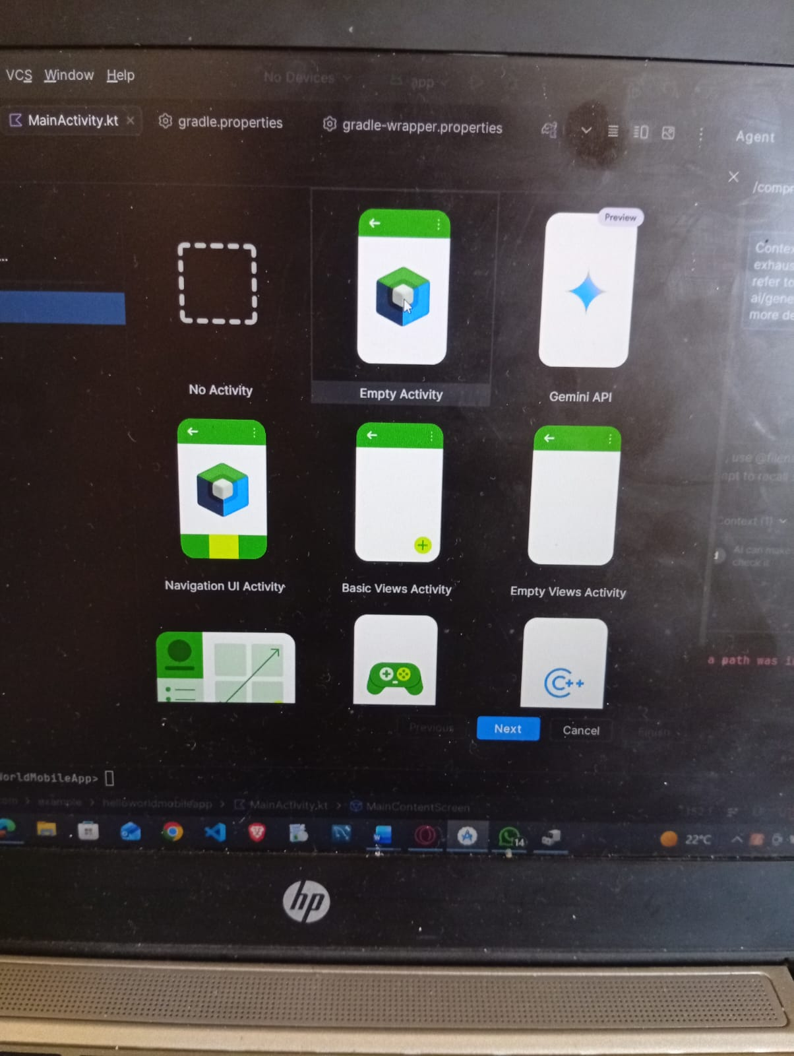
Project initialization and activity selection

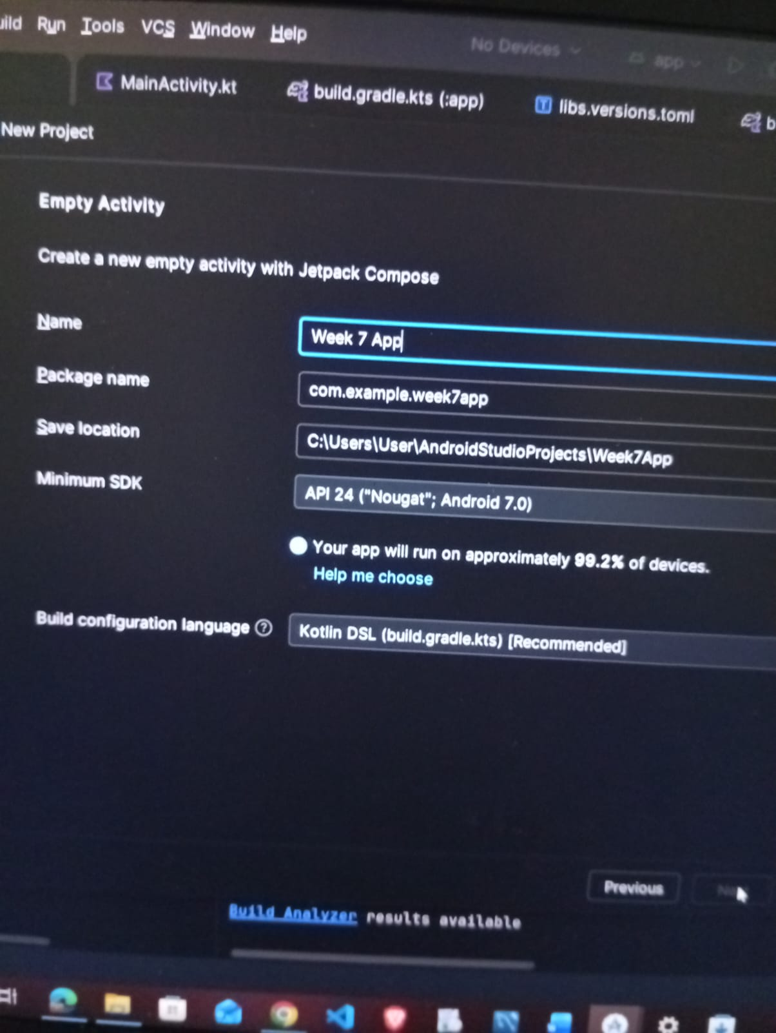
Configuring Project Details and SDK Settings

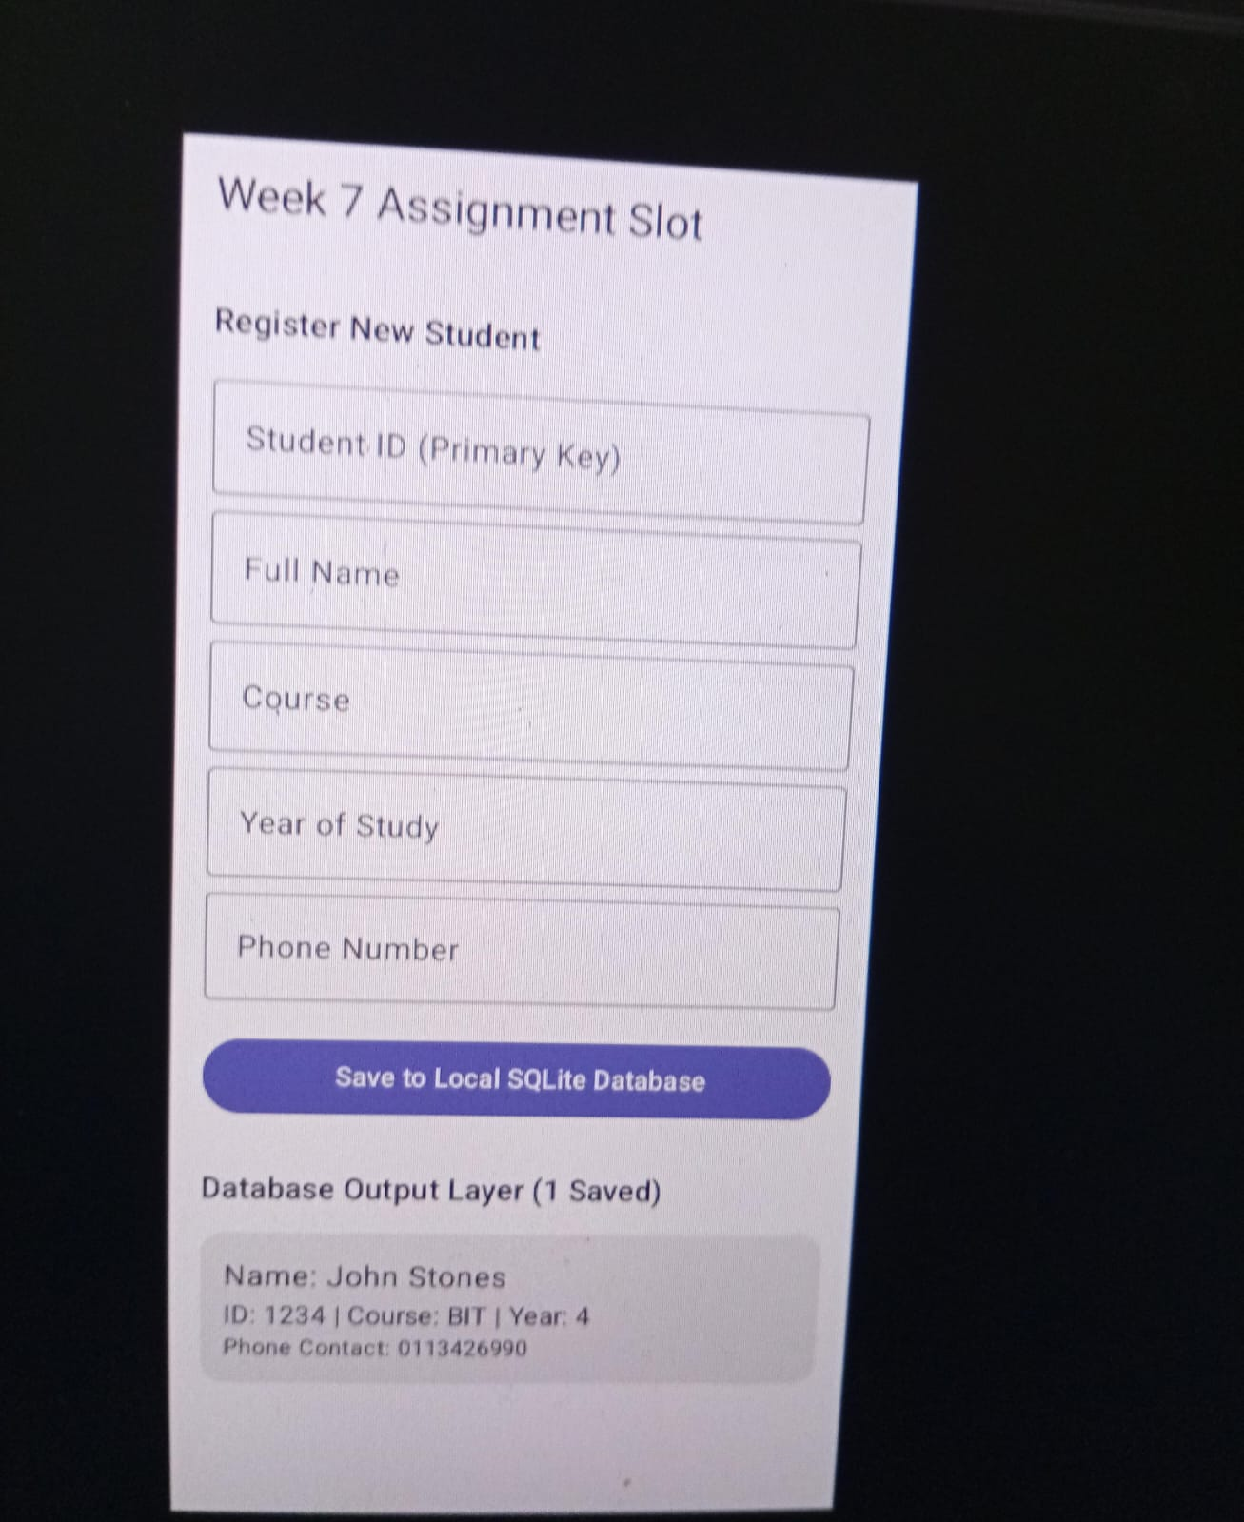
Application UI and local SQLite Database Verification

